Cultural Tour of Cuenca (full-day): includes guide, professional driver, and lunch at a local restaurant (private)
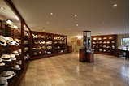 | 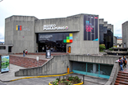 | 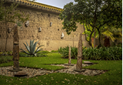
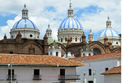 | 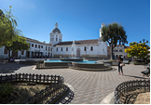 | 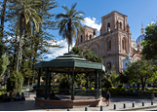
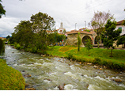 | 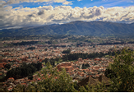 | 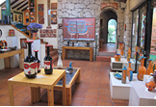
Santa Ana of the Rivers of Cuenca is the capital of Ecuador’s Azuay Province. The city was founded in 1557 by Spanish explorers and built on top of an ancient Cañari settlement, who were conquered by the Incas before the Spanish conquistadors arrived in the territory and built the town. It is home to magnificent colonial architecture and a rich, cultural and culinary tradition. Walking along the cobblestone streets while observing the unique dynamic between classical styles and modern life in Cuenca is a wonderful experience. The city is located at 8,366 ft (2,550 m) above sea level, the climate is moderate, and temperatures tend to be cooler, averaging about 63°F (17°C). Cuenca is a conservative, yet cosmopolitan city, with a great sense of artistic expression.
On this day, visitors are treated to an intimate look at a town full of so much traditional, architectural beauty that it is regarded as the “Athens of Ecuador”. Here, religious heritage is visible around every corner. The Sagrario Cathedral is one of the most recognizable and beautiful buildings in Cuenca. Built in 1557, its many hallways and altars bear witness to the numerous changes undergone over several decades. Interestingly, the bell tower was used as reference by the French Geodesic Mission in the 18th century to measure the Earth's terrestrial meridian.
One of the main attractions of our tour in Cuenca revolves around the famous, yet mistakenly named, "Panama Hat”, which actually originated in Ecuador. The city is home to many of the hat’s top manufacturers. The Magic of the Hat Museum, presented by Homero Ortega’s hat company, reveals the history and production process behind this beautiful accessory. Located inside the company’s own factory, visitors get the chance to participate in the hat making process.
The Pumapungo Central Bank Museum, otherwise known as the “Door of the Puma”, is the only archaeological site located within the urban area of Cuenca. This ancient Cañari and Incan settlement, which was later dismantled by the Spanish conquistadors to build their new city, houses a large collection of ethnographic items from the region, including: ancient textiles, everyday clothing, ceremonial garments, jewelry, ceramics, and more.
On this tour, we visit the Municipal Museum of Modern Art. Constructed in 1876, the building first functioned as an institutional facility. Over a century later, it was reimagined as a museum. Being that the most important Contemporary Art Biennial of the continent is held here, it houses an important and varied collection of modern art, which includes itinerant paintings, ink drawings, engravings, photography, sculptures, and more. The dynamic that exists here, between the traditional and the modern, is echoed throughout this marvelous city.
The New Cathedral, also known as the Cathedral of the Immaculate Conception or Cuenca Cathedral, boasts tall brick walls and three giant blue domes (brought in all the way from Czechoslovakia –now, the Czech Republic-). Its stained-glass rosettes emulate those of Notre Dame. Additionally, it holds a magnificent collection of religious art. The construction of this cathedral began in 1885 and was completed 82 years later. With its combination of Neo-Gothic, Romanesque, and Neo-Renaissance styles, it became one of Ecuador’s most important structures.
The architecture on display in Cuenca is almost always accompanied by colorful flowers and beautiful trees. This style of landscaping is itself worth admiring. The carefully designed gardens, fountains, and paths of San Sebastian Plaza, surrounded by the Contemporary Art Museum, the Larrazabal Gallery, and the Spanish-style San Sebastian Church, which features a single-towered facade and dome.
Cuenca’s Main Square, also known as Calderon Park, has gone by many names over the years. The square is surrounded by some of Cuenca's most iconic buildings: the Old Cathedral, the imposing and colorful Court of Justice to the southeast, the New Cathedral to the west, and Azuay's Government Building to the northeast. Also, it is home to many restaurants and shops that provide the Square with its unique ambience, making it one of Cuenca's favorite meeting points for many generations that continue to gather there daily.
Walking along the Tomebamba River, one of the four that go through Cuenca, is an opportunity not to be missed. The river traverses the city, separating newer neighborhoods from more traditional ones. It passes along beautiful parks and the famous barrio of El Barranco, with over 120 heritage buildings that create a beautiful landscape and fascinating arts district. The neighborhood’s iconic Calle Larga and 12 de Abril Avenue are not to miss.
The Turi Viewpoint, which features the Turi Church, is one of the best spots from which to admire the city at a distance. From this location, just a few minutes outside of town, Cuenca’s typical orange tile roofs, modern buildings, wide avenues, emerald parks, and iconic church towers and domes inspire visitors by creating a visual feast of colors and shapes.
Just 328 ft (100 m) away from the scenic lookout at Turi is the gallery of Cuenca's most renowned ceramic artist and muralist, Eduardo Vega. Here, visitors can observe his work. Each piece captures the passion and originality of Vega’s vision.
We will have lunch at a local restaurant.
Notes
- Daily tour from Cuenca lasting approximately 8 hours.
- This tour includes walking at an altitude of 8,366 ft (2,550 m).
Recommendations
- Dress in layers and bring a warm sweater and jacket.
- Wear comfortable walking shoes or hiking boots.
- Bring a hat, sunglasses, and sun protection (SPF 40+).
- Bring a raincoat or umbrella.
Included
- Private guide and professional driver, lunch, and all entrance fees.
Not Included
- Drinks, tips, personal expenses.

